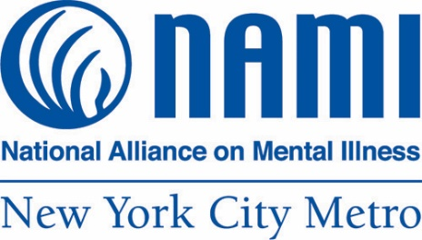

Candid Conversations:
Talking about Mental Health in NYC Latino Communities

Letter from Our CEO

Dear Friends,

NAMI-NYC is proud to present this toolkit aiming to start candid conversations and break the stigma around mental health challenges in the Latino community.

NAMI-NYC has 40 years of experience helping families and individuals affected by mental illness. NAMI-NYC is peer-led and peer-run, which means that most of our Board, staff, and our over 300 volunteers have lived experience with mental illness personally or caring for a loved one. We understand because we live it.

As we develop our Spanish language programs, including our Helpline with expanded interpretation in Spanish and 180 languages, Basics, Family-to-Family, and our support group, we are not only translating but creating culturally responsive programs.

As with NAMI-NYC's programs, to develop this PSA and this toolkit, we spoke to New Yorkers to understand their needs and to develop language and images that resound with the community. Thank you to our Video Producer Lorena Valencia for sharing these insights and to our community partners for amplifying this toolkit among New Yorkers.

Thank you to OMH for funding this important initiative and for your guidance.
We hope that you find this PSA helpful and we welcome your partnership!
Please reach out at communications@naminyc.org.

Matt Kudish
CEO, NAMI-NYC

The Video: Watch Now

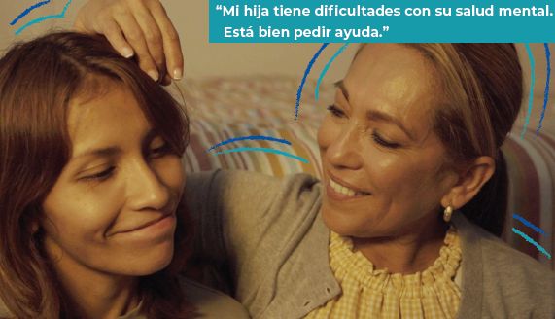

This video was created after talking to friends and neighbors in the community. We wanted to reach New Yorkers who have not yet experienced NAMI-NYC or its programs. NAMI-NYC participants are already willing to talk about their mental health and the mental health of their loved ones. And through our evidence-based classes, participants learn key principals that reduce their stigma over time -- that mental illness is a treatable condition separate from themselves or their loved one. We found that there was great apprehension to discuss mental health in the community and certainly a discomfort with using the words, "mental illness."

NAMI-NYC is one of the only organizations providing support to family members caring for loved ones experiencing mental health challenges. We want families to know that there is help available for them and with support, relationships improve.

Many family members, parents, adult children, siblings, partners, come to NAMI-NYC distressed. They don’t know how to navigate the mental health care system. They don't know how to support or communicate effectively with their loved one.

Sometimes, it's a roller coaster with no roadmap. And then there are further barriers like language, lack of health insurance, or undocumented status. But with tools and resources, caregivers better understand their loved one's mental illness and how to help. And they can achieve this by helping themselves first.

Our PSA video features a mother and adult daughter who were once close. We see this from a glimpse of a happy photo of them on the dresser. The mother, like many caregivers, has tried everything to reach out to her daughter, but her wall of defenses remains up. The mother washes her face, exhausted, tired, and resigned. She realizes that it is not just her daughter who needs help. Mom needs help too. This acceptance is the first step towards recovery for caregivers and the family unit. Once the mother realizes that she needs help, there's hope to repair the relationship and family dynamics.

This video is available on our website and YouTube channel. Here are various ways that you can engage with this PSA.

Send An Email

You can spread the word by sharing this email with your family, friends, colleagues, and neighbors. Here is a sample message.

Dear Friend,

Hope all is well. I wanted to share this video with you. The National Alliance on Mental Illness of New York City (NAMI-NYC) talked to Latino community members to learn more about their needs, their experiences, and how they talk about mental health.

Family caregivers of people living with mental illness do not always ask for help. NAMI-NYC's Video Producer and Mexican filmmaker Lorena Valencia, who directed and created this PSA, wanted to show how important and monumental it is just to start the conversation.

When you can break the silence, it is possible to mend family relationships. It is possible to learn about and access family education, support, and community.

View the video: https://youtu.be/wudyDigIHFM

Share our video and forward this message to your family, friends, colleagues, and your community. You can break the silence!

Host a Community Discussion
You can host a discussion as long or as brief as you would like. We would recommend hosting a session at least 30 minutes long. You can convene your staff, a group of friends, nonprofit participants, a church group, or book club – get creative!
Designate a group leader and start with the following questions:

Watch the video together and answer the following questions:
- How did the video resound with you?
- What is your experience talking about mental health in your family?
- As a Latino, what barriers have you faced in accessing mental health care?
- What mental health services, support, or community have worked for you and your family?
- What does self-care mean to you?
- Would you share the video with others?

Share your observations and findings of your community discussion with us at communications@naminyc.org. You can also take photos or screenshots of any in-person or virtual discussion and tag NAMI-NYC.

Share On Social

Here is some original content for you to share.

Messages:
- Let’s start the conversation about mental health. Created by NAMI-NYC. Funded by NYS Office of Mental Health. https://youtu.be/wudyDigIHFM
- 1 in 5 New Yorkers experience mental illness. The other 4 are our family, friends, colleagues, and neighbors. Created by NAMI-NYC. Funded by NYS Office of Mental Health. https://youtu.be/wudyDigIHFM
- Mental health affects us all, including the Latino community. Created by NAMI-NYC. Funded by NYS Office of Mental Health. https://youtu.be/wudyDigIHFM

Share Your Story

We have learned so much from our community and we want to hear from you! Please submit your story and we'll share it on our website. What have you been through? What do we need to know to better support Latino families? Email us at communications@naminyc.org with “PSA: Share Your Story” in the subject line.

Spread the Word in Your Community

Let your friends, family, and neighbors know that free help and support is available. Download this Spanish programs one pager and posters to display in your community. You can post these materials in various locations:
- School
- College
- Church
- Nonprofit
- Food bank
- Library
- Community Center

Download One Pager
Download Poster

Refer A Friend

Do you know anyone who may benefit from our services in Spanish? Refer a friend here: helpline@naminyc.org. We’ll respond in 24-48 hours to any of your mental health care questions or concerns. Our Helpline is not for emergencies.

If you are a service provider, you can use our Rapid Referral form.
Some of our programs in Spanish, include:
- Family to Family Class
- Basics Class
- Family and Friends Support Group
- Helpline in English, Spanish, and 180+ languages

NAMI-NYC's services are free of charge and accessible to anyone who needs them regardless of income or immigration status. No insurance or diagnosis needed. All information participants share during classes and support groups remains confidential. Learn more at: https://www.naminycmetro.org/espanol/.

If you have any questions about this toolkit, please contact communications@naminyc.org.

